Recurrent Neural Networks (RNN) from Basic to Advanced
Ever wonder how your phone translates languages or predicts the next word you’re typing? It’s all thanks to something called a recurrent neural network, or RNN for short. Think of RNNs as super-smart machines that can learn from sequences, like sentences or music.
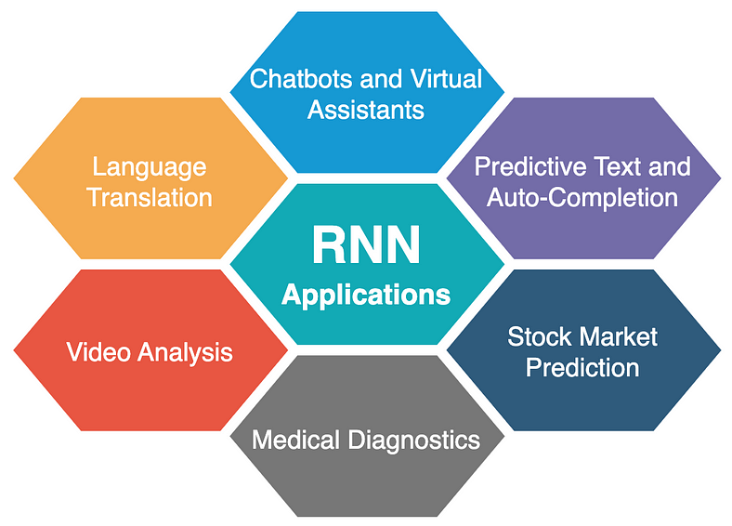
What is RNN?
Recurrent neural networks (RNNs) are a type of artificial neural network specifically designed to handle sequential data.
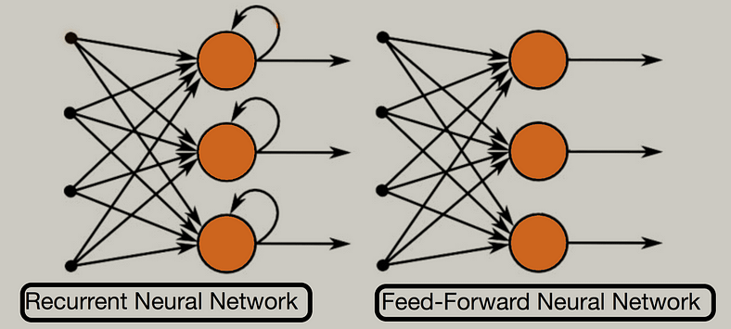
ANNs and CNNs are example of Feed-Forward Neural Network while In RNNs, Information can flow back and forth through internal loops, allowing the network to consider past information when processing the current input.
Unlike traditional neural networks where each input is independent, RNNs can access and process information from previous inputs. This makes them particularly useful for tasks that involve sequences, like text, speech, or time series data.
What is Sequential data?
Sequential data is information that has a specific order and where the order matters. Each piece of data in the sequence is related to the ones before and after it, and this order provides context and meaning to the data as a whole.
Here are some other common types of sequential data:
Time series data: This refers to data points collected at regular intervals over time. Examples include stock prices, temperature readings, or website traffic. The order of the data points matters because it shows how the value changes over time.
Natural language text: All written language is sequential. The order of words in a sentence or paragraph is essential for conveying meaning and understanding the relationships between ideas.
Speech signals: Spoken language is another example of sequential data. The order of sounds like phonemes, syllables, and words is crucial for understanding the spoken message.
Why use RNN?
Traditional Artificial Neural Networks (ANNs) are powerful tools, but they struggle with sequential data like text because they require fixed-size inputs. Each input in an ANN is treated independently, making them unsuitable for tasks where the order and relationships between elements are crucial.
Suppose if we use zero padding concept in which shorter sequences are padded with zeros at the end to reach the length of the longest sequence in the batch. These zeros act as placeholders and don’t carry any meaningful information. Padding introduces irrelevant zeros that the network needs to process alongside the actual data, increasing computational burden.
And also due to no sequences in passing input in ANN, we loss the context or sequential information. Apart from this if any user gives the input length of higher size that we expect then in that scenario we can nothing. For ex. we set our input size is 5 words but any user gives it 15 words at a time then in that case we can’t handle it with ANN.
कहानी: गांव के स्कूल में RNN की खोज

गांव का स्कूल

मान लीजिए, आप एक छोटे से गांव में एक स्कूल के अध्यापक हैं। स्कूल में बच्चों की कक्षाएँ होती हैं और आप हमेशा उन्हें नई-नई कहानियाँ सुनाते हैं। आपकी कहानियाँ बच्चों को बहुत पसंद आती हैं, क्योंकि आप हर कहानी में कुछ नया और मजेदार जोड़ते हैं। अब, सोचिए कि आपके पास एक खास दिमागी खेल है, जो आपकी कहानियों को और भी दिलचस्प बनाता है। इसी तरह के दिमागी खेल की तरह ही, एक Recurrent Neural Network (RNN) काम करता है।

खेल की शुरुआत

हर दिन स्कूल में बच्चों को एक नई कहानी सुनाई जाती है। मान लीजिए आज आप एक कहानी सुनाते हैं जिसमें एक राजा, एक घोड़ा, और एक जादूगर हैं। कहानी की शुरुआत राजा के घोड़े को खोजने से होती है और जादूगर की मदद से अंत में घोड़ा मिल जाता है।

अब आप सोचते हैं कि कैसे आप अपनी अगली कहानी में पिछले दिन की कहानी से जुड़े हुए संकेतों को शामिल कर सकते हैं। यही काम एक RNN करता है, लेकिन यह काम बहुत ही खास तरीके से करता है।

RNN की कहानी

1. पहला दिन: शुरुआत

आप आज की कहानी के साथ शुरुआत करते हैं, बच्चों को बताकर कि राजा और घोड़ा फिर से एक नई यात्रा पर निकलने वाले हैं। इसी तरह, RNN अपने इनपुट \(x_t\) से शुरू करता है।

2. यादों का खजाना: Hidden State

पिछले दिन की कहानी में घोड़े के बारे में जो कुछ भी आपने बताया था, वह आपके दिमाग में एक ‘याद’ की तरह बसी हुई है। RNN के पास एक Hidden State \(h_t\) होता है, जो समय के साथ पिछली जानकारियों को याद करता है और उसे अपडेट करता है।

Hidden State (h_t):
यह राजा और घोड़े की यात्रा की पिछली जानकारी को समेटे हुए है। जब आप नई कहानी शुरू करते हैं, यह Hidden State पिछले दिन की कहानी के तत्वों को नए दिन की कहानी में जोड़ता है।

3. कहानी में नया मोड़: अगला कदम

जैसे ही आप कहानी को आगे बढ़ाते हैं, राजा और घोड़े नई चुनौतियों का सामना करते हैं। इसी तरह, RNN हर Time Step पर अपने Hidden State को अपडेट करता है ताकि हर समय की जानकारी को संभाल सके।

4. कहानी की शुरुआत का असर: Output

जैसे आपकी कहानी के अंत में बच्चे एक नई सीख के साथ घर जाते हैं, RNN के Output \(y_t\) से भविष्य की भविष्यवाणी की जाती है। यह Output RNN के Hidden State पर आधारित होता है, जो पुरानी जानकारियों से नया निष्कर्ष निकालता है।

5. सीखना और सुधारना: Backpropagation

अगर आपकी कहानी में कोई गलती हो जाती है, आप अगली बार बेहतर तरीके से कहानी सुनाते हैं। RNN भी इसी तरह Backpropagation Through Time (BPTT) करता है। इसमें RNN अपने पिछले अनुभवों से सीखता है और अपने पैरामीटर्स को सुधारता है ताकि भविष्य में बेहतर प्रदर्शन कर सके।

सारांश

इस तरह, RNN एक ऐसे शिक्षक की तरह है जो हर दिन की कहानी से सीखता है और उसे अगली कहानी में लागू करता है। यह समय के साथ नई जानकारी को समझता है और याद रखता है, जिससे वह पिछले अनुभवों से भविष्य की भविष्यवाणी कर सकता है।

आखिरी शब्द

रुको, सोचिए इस कहानी में कितनी बातें जुड़ी हुई हैं। RNN भी वैसे ही काम करता है - पिछली जानकारी को याद करता है, समय के साथ सीखता है, और नए अनुभवों को जोड़कर भविष्य की भविष्यवाणी करता है। आपके जैसे शिक्षक की तरह, जो बच्चों को हर दिन नई कहानियाँ सुनाते हैं, RNN भी हर समय पर अपने Hidden States को अपडेट करता है और Output देता है।

कैसे RNN काम करता है:

- Input (x_t): नई कहानी का पहला हिस्सा।
- Hidden State (h_t): पिछले दिन की कहानी की यादें।
- Output (y_t): नई कहानी की भविष्यवाणी।
- Backpropagation Through Time (BPTT): पिछले अनुभवों से सीखना और सुधारना।

इस कहानी के माध्यम से, आप देख सकते हैं कि RNN कैसे समय के साथ जानकारी को संभालता है और सीखता है। यह प्रक्रिया बिल्कुल वैसी ही है जैसे आप अपनी कहानियों को बच्चों के लिए और भी बेहतर बनाते हैं।

The hyperbolic tangent (tanh) activation function is commonly used in Recurrent Neural Networks (RNNs) due to several advantageous properties:

1. Range and Centering: The tanh function outputs values in the range [-1, 1], which makes the output zero-centered. This helps to mitigate issues related to data being biased towards positive values, leading to more effective training.

2. Gradient Properties: The derivative of the tanh function is 1 - tanh^2(x), which means that it can have gradients that are neither too large nor too small. This property helps in maintaining the gradients within a reasonable range, which is crucial for backpropagation through time (BPTT) in RNNs.

3. Non-linearity: The tanh function introduces non-linearity to the model, which is essential for learning complex patterns and relationships in the data. Non-linear activation functions like tanh allow the network to capture intricate dependencies in sequential data.

Mathematical Formulation

The tanh function is mathematically defined as:

tanh(x) = (e^x - e^{-x}) / (e^x + e^{-x})

The derivative of the tanh function, which is used during backpropagation, is given by:

d/dx tanh(x) = 1 - tanh^2(x)

Application in RNNs

In RNNs, the tanh function is typically used in the hidden state update equation. Given an input x_t at time step t and the previous hidden state h_{t-1}, the hidden state h_t is updated as follows:

h_t = tanh(W_h h_{t-1} + W_x x_t + b)

where:
- W_h and W_x are weight matrices for the hidden state and input, respectively.
- b is the bias vector.

The use of the tanh function in this context helps to keep the values of the hidden states within a manageable range, preventing issues like exploding gradients.

How Recurrent Neural Networks (RNNs) Work

Recurrent Neural Networks (RNNs) are a class of artificial neural networks designed to handle sequential data and learn from temporal dependencies. Unlike traditional feedforward neural networks, RNNs have connections that form directed cycles, allowing them to maintain information across time steps. Here’s a detailed overview of how RNNs work:

1. Basic Structure

An RNN processes sequences of data by iterating through the data and maintaining a hidden state that captures information from previous time steps. The basic structure of an RNN cell is as follows:

- Input (x_t): Data at the current time step t.
- Hidden State (h_t): Memory of the previous time steps, updated at each time step.
- Output (y_t): Prediction or result at the current time step t.

2. Forward Pass

At each time step, the RNN performs the following operations:

1. Compute Hidden State:
The hidden state h_t is updated using the current input x_t and the previous hidden state h_{t-1}:
```
h_t = Activation(W_h * h_{t-1} + W_x * x_t + b)
```
- W_h: Weight matrix for the hidden state.
- W_x: Weight matrix for the input.
- b: Bias vector.
- Activation: Commonly tanh(x) or ReLU(x).

2. Compute Output:
The output y_t is calculated based on the hidden state h_t:
```
y_t = W_y * h_t + b_y
```
- W_y: Weight matrix for the output.
- b_y: Bias for the output.

3. Loss Computation

The network’s performance is evaluated using a loss function, which measures the difference between the predicted output y_t and the actual target y_t_target:
```
Loss = Loss Function(y_t, y_t_target)
```

4. Backpropagation Through Time (BPTT)

To train the RNN, gradients of the loss function are computed with respect to the weights. This process involves:

1. Calculating Gradients:
Compute the gradients of the loss with respect to the parameters (W_h, W_x, W_y, b, b_y) through the entire sequence of time steps.

2. Updating Parameters:
Update the parameters using gradient descent or another optimization algorithm:
```
W <- W - η * ∂Loss/∂W
```
- η: Learning rate.

5. Handling Sequences

RNNs can handle sequences of varying lengths. During training, sequences are often padded to a uniform length or truncated, and techniques like sequence masking can be used to handle different lengths.

6. Types of RNNs

- Vanilla RNNs: The basic form of RNNs with simple recurrent connections.
- Long Short-Term Memory (LSTM) Networks: A type of RNN designed to capture long-term dependencies and mitigate issues like vanishing/exploding gradients. LSTMs have additional gates (input, forget, and output) to manage information flow.
- Gated Recurrent Units (GRUs): A variation of LSTMs with a simpler architecture but similar capabilities.

RNNs are powerful for modeling sequential data due to their ability to maintain state information across time steps. They process sequences one element at a time, update hidden states to capture dependencies, and use backpropagation through time to learn from the entire sequence.

How RNNs works?
The diagram depicts a simplified sentiment analysis process using a Recurrent Neural Network (RNN). Sample text is assigned sentiment labels (0/1 for positive/negative). Unique words are converted to numbers for the RNN to understand. These numbers are fed into the RNN one by one, with each word considered a single time step in the sequence. This demonstrates how RNNs can analyse sequential data like text to predict sentiment.
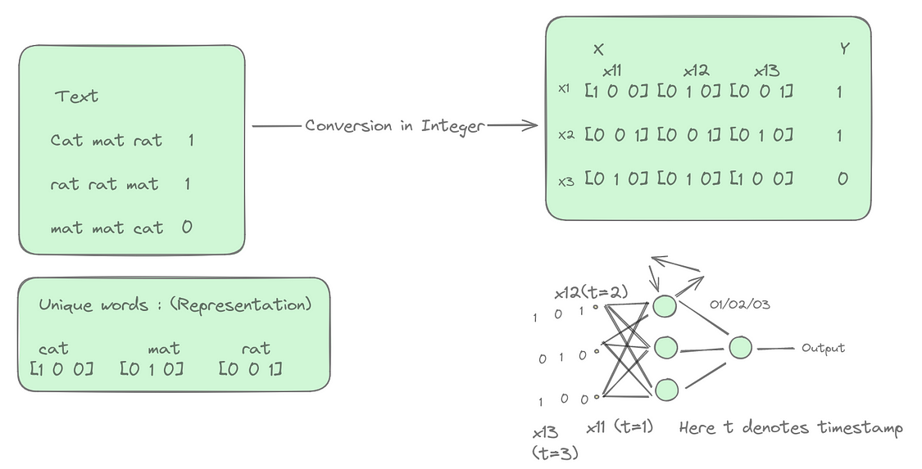
Let’s say input weights are denoted by wi, output weights with wo, feedback loop weights with wh and biases for first hidden layer is bi and bias for output layer is bo, then mathematical formulation for above is given by :
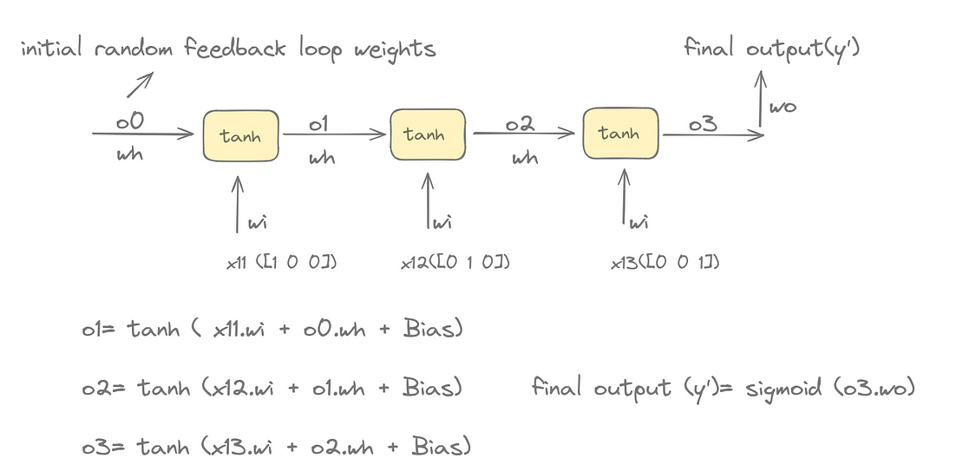
Types of RNN Architecture:
There are 3 types of RNN architecture which are:
One to Many
Many to One
Many to Many
1. One to Many:
In recurrent neural networks (RNNs), a “one-to-many” architecture represents a scenario where the network receives a single input but generates a sequence of outputs. This is the opposite of a many-to-one RNN.
Single Input: The RNN takes in a single piece of information as input. This could be an image, a musical note, a short sentence, or any data point that serves as a starting point for the network.
Multiple Outputs: The RNN processes the input and generates a sequence of outputs over time. This sequence can vary in length depending on the specific task.
Here are some common applications of one-to-many RNNs:
Image Captioning: Based on a single image input, the RNN generates a sentence or paragraph describing the image content (multiple outputs).
Music Generation: The RNN receives a single starting note or short melody as input and produces a sequence of musical notes forming a complete piece (multiple outputs).
2. Many to One:
In recurrent neural networks (RNNs), a “many-to-one” architecture refers to a specific type of RNN where the network processes a sequence of inputs but produces a single output.
Here’s a breakdown of how it works:
Many Inputs: The RNN takes in a sequence of data points over time. This sequence could be words in a sentence, sensor readings over a period, or financial data points for multiple days.
Single Output: After processing the entire sequence, the RNN generates a single output value. This output could be a classification (positive/negative sentiment), a prediction (next value in the time series), or a summary of the information in the sequence.
Here are some common applications of many-to-one RNNs:
Sentiment Analysis: Given a sentence or review text (sequence of words), classify its overall sentiment (positive, negative, or neutral) as the single output.
Spam Detection: Analyze an email’s content (sequence of words) to determine if it’s spam (single output).
3. Many to Many:
In recurrent neural networks (RNNs), a “many-to-many” architecture describes a scenario where the network processes a sequence of inputs and generates a corresponding sequence of outputs. This means both the input and output have multiple elements processed over time steps.
Here’s a breakdown of the concept:
Multiple Inputs: The RNN takes in a sequence of data points, similar to many-to-one RNNs. This sequence could be words in a sentence, sensor readings, or financial data points.
Multiple Outputs: The RNN generates a new sequence of data points, with a length that may or may not be the same as the input sequence.
There are two main categories of many-to-many RNNs:
Fixed Length: In this case, the number of elements in the output sequence is the same as the number of elements in the input sequence. A common application is named entity recognition (NER), where the network identifies and classifies each word in a sentence (input sequence) as a specific entity type (i.e. parts of speech) (output sequence).
Variable Length: Here, the output sequence can have a different length than the input sequence. This is particularly useful for tasks like machine translation, where the source sentence (input sequence) in one language might be translated into a longer or shorter sentence (output sequence) in another language.
Common Applications of Many-to-Many RNNs:
Machine Translation: Translate text from one language to another (e.g., English to French).
Video Captioning: Generate captions describing the content of a video (sequence of video frames as input, sequence of words as output).
Text Summarization: Summarize a long document into a shorter version with key points (sequence of sentences as input, shorter sequence of sentences as output).
Network Architectures for Many-to-Many RNNs:
A common approach for many-to-many RNNs is the encoder-decoder architecture. Here, the network is divided into two parts:
Encoder: This part processes the input sequence and captures its meaning in a hidden representation.
Decoder: This part takes the hidden representation from the encoder and generates the output sequence element by element.
Important note: - One to One architecture is not a type of RNN because a one-to-one situation involves a single input and a single output, with no concept of sequence. However, for this specific task (single input to single output), both Convolutional Neural Networks (CNNs, for example image classification) and Artificial Neural Networks (ANNs) can be suitable candidates, depending on the nature of the input data.
Backpropagation in RNNs:
Backpropagation in RNNs, also known as Backpropagation Through Time (BPTT), is a crucial technique for training these networks. It allows them to learn and improve their performance on tasks involving sequential data.
Let’s take an example to understand the back propagation in many to one RNNs architecture:
1. Forward Pass:
The RNN processes a sequence of inputs one step at a time. At each step, the current input and the previous hidden state are fed into the network’s activation function to generate a new hidden state and an output.
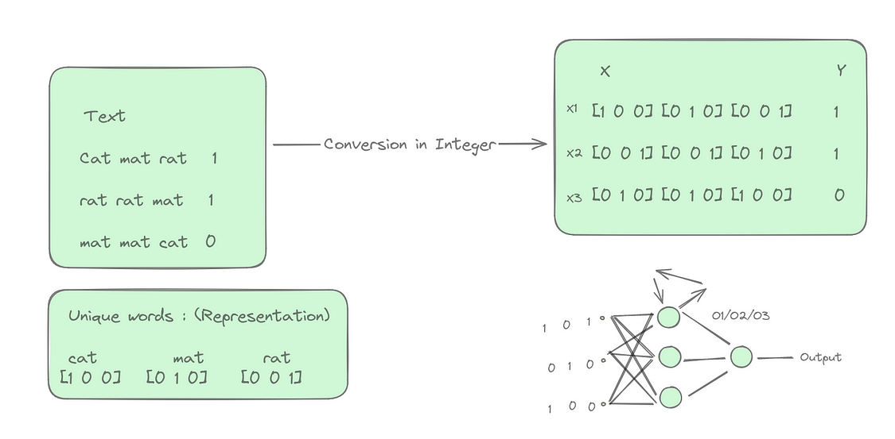
2. Error Calculation:
After processing the entire sequence, the difference (error) between the network’s final output and the desired output for the sequence is calculated.
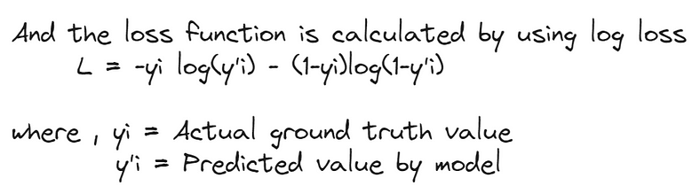
3. Weight Update:
Using the gradients, the weights in the actual RNN are adjusted in a way that will minimize the error in future predictions. Weights that significantly contributed to the error are adjusted more than those with minimal influence. Update of weights are calculated as shown in the figure:
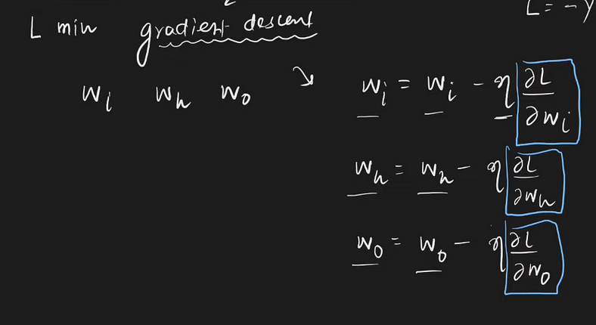
For calculating gradient, the following dependency needs to be understood:
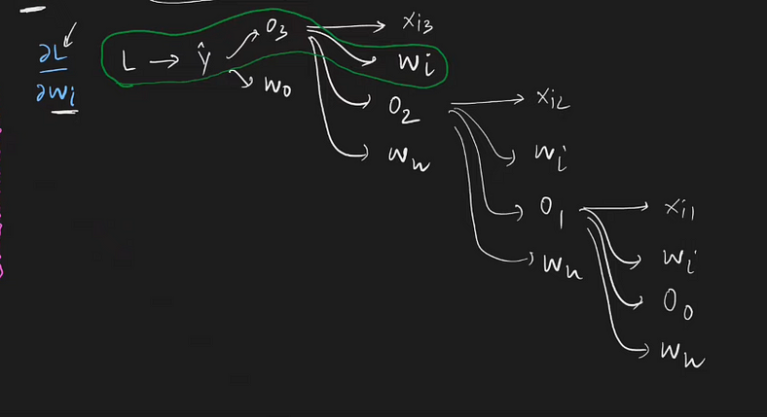
And after understanding above dependency we can write the gradient w.r.t. to wi in the following way :
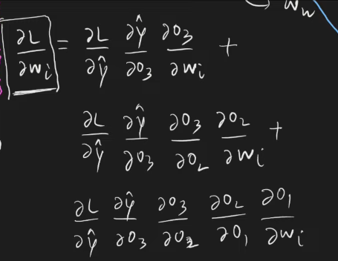
We can also write above equation in the following way also:
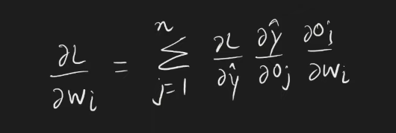
Problems with RNNs:
Vanishing Gradient Problem:
This is a major hurdle for RNNs, especially vanilla RNNs. It occurs when gradients (signals used to update weights during training) become very small or vanish as they propagate backward through the network during BPTT. This makes it difficult for the network to learn long-term dependencies in sequences, as information from earlier time steps can fade away.
In RNNs, information from previous time steps is used to influence the current output. This is achieved by feeding the output of a layer back as input to the next layer in the sequence. However, during back propagation through these layers:
Gradients are multiplied by weights at each step.
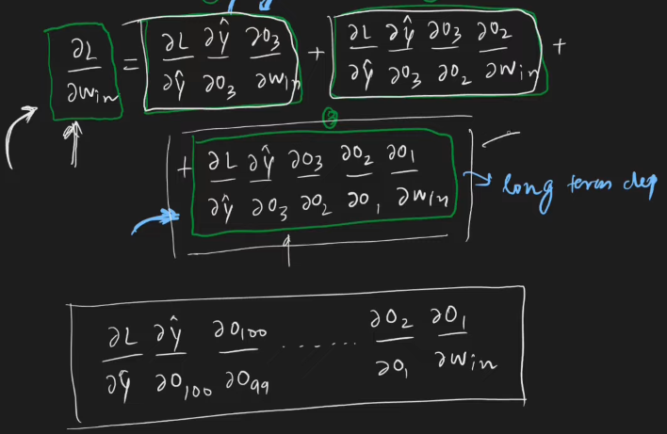
If these weights are all less than 1 in absolute value, this product becomes progressively smaller as we go back in time. This shrinks the error gradients for earlier time steps, making it difficult for the network to learn long-term dependencies present in the sequence.
RNNs struggle to learn from long sequences due to vanishing gradients. This makes them unsuitable for tasks like predicting future events based on long passages. However, RNNs excel at analysing recent inputs, which is perfect for short-term predictions like suggesting the next word on a mobile keyboard.

